**DIVISION OF DATA SCIENCE AND CYBER SECURITY**

**SCHOOL OF ENGINEERING AND TECHNOLOGY**

**SKILL BASED EVALUATION REPORT**

**SUBMITTED BY**

**BHARATH KUMAR S (URK22AI1030)**

**Guided by**

**Ms. T.Kavitha M.Tech (Ph.D)**

**COURSE CODE**

**20CS2006**

**COURSE NAME**

**COGNITIVE COMPUTING**

**October 2024**



**DIVISION OF DATA SCIENCE AND CYBER SECURITY**

**BONAFIDE CERTIFICATE**

This is to certify that the project report entitled, **“SmartEcom Solution”** is a bonafide record of Mini Project work done during the odd semester of the academic year 2024-2025 by

**BHARATH KUMAR S (URK22AI1030)**

in partial fulfillment of the requirements for the award of the degree of Bachelor of Technology in Artificial Intelligence and Data Science of Karunya Institute of Technology and Sciences.

Submitted for the Viva Voce held on24.10.2024.

**Signature of the Guide**

**CERTIFICATE**

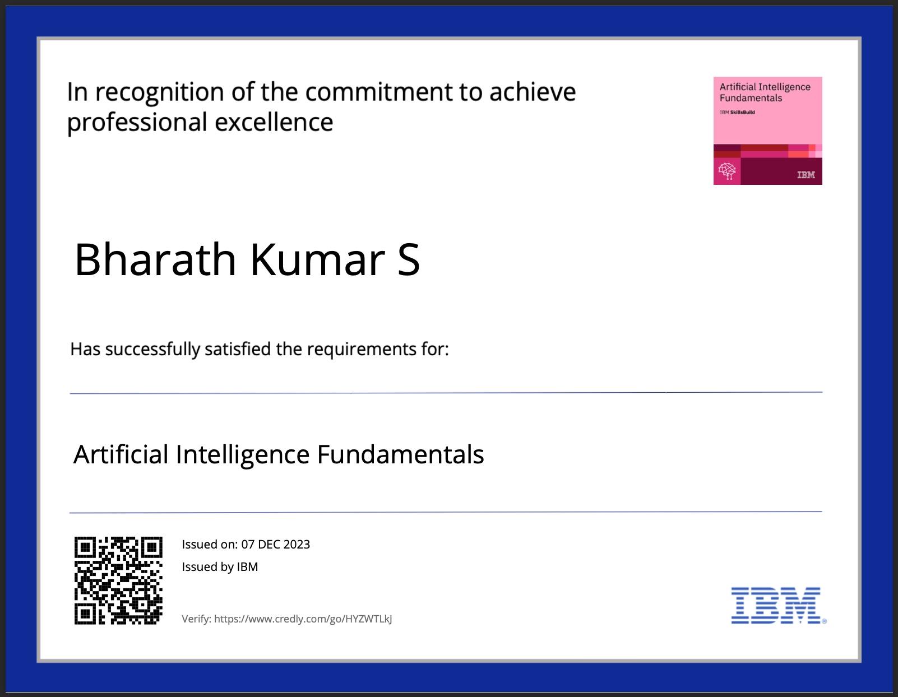

# **ACKNOWLEDGEMENT**

First and foremost, I praise and thank ALMIGHTY GOD whose blessings have bestowed in me the will power and confidence to carry out my project.

I am grateful to our beloved founders Late**. Dr. D.G.S. Dhinakaran, C.A.I.I.B, Ph.D** and **Dr. Paul Dhinakaran, M.B.A, Ph.D**, for their love and always remembering us in their prayers. I extend my thanks to our Vice Chancellor **Dr. Prince Arulraj, M.E., Ph.D.,** and our

Registrar **Dr. S. J. Vijay, M.E., Ph.D,** for giving me this opportunity to do the project.

I wish to extend my thanks to our Pro-Vice Chancellors, **Dr. E.J. James**, **Dr. Ridling Margaret Waller** and **Dr. Elijah Blessing**, for providing me this opportunity to do the project.

I would like to thank **Dr. Ciza Thomas.,** Dean, School of Computer Science and Technology for his direction and invaluable support to complete the same.

I would like to place my heart-felt thanks and gratitude to **Dr. Grace Mary Kanaga E, M.Tech., Ph.D.,** Head of the Division, Data Science and Cyber Security for her encouragement and guidance.

I feel it is a pleasure to be indebted to, Ms.T.Kavitha assistant Professor, Division of Data Science and Cyber Security for his/her invaluable support, advice and encouragement.

I also thank all the staff members of the Division for extending their helping hands to make this project a successful one.

I would also like to thank all my friends and my parents who have prayed and helped me during the project work.

# **ABSTRACT**

This project focuses on developing a cognitive system that integrates WhatsApp to streamline customer interaction through AI-powered product recommendations. The system allows users to send voice orders via WhatsApp, which are converted to text using speech recognition technology. This text is then processed by an AI model that analyzes user input and generates personalized product suggestions. Finally, the system converts these suggestions back into audio format and sends them to the user through WhatsApp, creating a seamless, user-friendly interaction.

The WhatsApp Business API serves as the platform’s interface, enabling real-time communication. Speech recognition technologies, like Python’s SpeechRecognition and PyDub, handle voice-to-text conversion, ensuring accurate transcription of user input. The AI model, built on natural language processing (NLP) and machine learning, provides context-aware, tailored recommendations based on user preferences and previous interactions. The text-to-speech (TTS) functionality, using libraries such as Google Text-to-Speech (gTTS) and pyttsx3, returns high-quality audio responses, making the interaction more dynamic and accessible.

The system enhances customer support by offering personalized suggestions quickly and efficiently, improving the overall shopping experience. With reinforcement learning integrated into the AI, the model adapts to evolving user behaviors, continuously improving its recommendation accuracy. This project demonstrates the potential of combining NLP, machine learning, and messaging platforms to create a more engaging and intuitive customer service tool. Future expansions could include multilingual support, sentiment analysis, and integration with other platforms to further enhance the system’s capabilities.

**CONTENT**

**1. Introduction 07**

**2. Objective 08**

**3. System Design 09**

**3.1 Requirements Analysis**

**3.2 System Architecture**

**3.3 Architectural Diagrams**

**4. Technologies Used 12**

**5. Implementation 13**

**6. Testing 16**

**Conclusion**

**1.INTRODUCTION**

In today's digital age, businesses are increasingly focused on providing seamless, personalized customer experiences. With the rise of messaging platforms such as WhatsApp, customers are looking for faster, more convenient ways to interact with companies. To meet these demands, businesses are turning to artificial intelligence (AI) and natural language processing (NLP) technologies to automate customer interactions and provide tailored recommendations. This project addresses these needs by developing a cognitive system that integrates WhatsApp with AI-driven product recommendation capabilities, enhancing user engagement and improving the overall shopping experience.

The core of this project lies in its ability to receive voice orders from users via WhatsApp, convert them into text using advanced speech recognition techniques, and then process the text to generate personalized product suggestions. These suggestions are based on user preferences, previous interactions, and product data, making them highly relevant. Once the suggestions are generated, the system converts the text back into an audio format and sends it to the user, offering a streamlined, intuitive interaction. This approach not only saves time for customers but also allows businesses to deliver more efficient and customized support.

WhatsApp, with its vast user base and ease of use, provides an ideal platform for implementing this system. The integration of technologies such as the WhatsApp Business API, speech-to-text conversion, natural language understanding, and text-to-speech synthesis forms the backbone of the project. This combination enables businesses to automate customer support in a way that feels personal and responsive, significantly improving customer satisfaction and engagement.

In this project, the use of machine learning techniques further enhances the system's ability to adapt to user behavior. Through reinforcement learning, the AI model continually improves its recommendation accuracy by learning from each user interaction. This ability to personalize suggestions in real-time and across different languages and accents makes the system a powerful tool for businesses seeking to enhance their digital customer service channels.

As companies strive to meet the growing expectations of consumers, this cognitive system exemplifies how advanced AI and NLP technologies can be harnessed to provide a modern, efficient, and personalized customer experience. With potential future expansions such as multilingual support, sentiment analysis, and integration with other communication platforms, this project represents a forward-thinking approach to solving the challenges of automated customer engagement in the e-commerce space.

**2.OBJECTIVE**

The primary objective of this project is to design and implement a cognitive system that integrates WhatsApp with AI-driven technologies to offer personalized product suggestions based on user voice input.

**Voice Message Processing via WhatsApp**:

Develop a system that can seamlessly receive and process voice messages from users through WhatsApp. This includes integrating the WhatsApp Business API to handle incoming and outgoing messages, allowing users to interact with the system using voice commands.

1. **Voice-to-Text Conversion**:

Implement a robust speech recognition system that accurately converts voice messages into text. By using Python-based libraries like SpeechRecognition and PyDub, the system will ensure precise transcription of voice input, accounting for different accents and potential background noise.

1. **AI-Driven Product Suggestions**:

Utilize an AI model to process the transcribed text, analyze user preferences, and generate personalized product suggestions. The model will be trained to understand user behavior and preferences, providing context-aware recommendations that align with the user’s needs and prior interactions.

1. **Text-to-Speech Conversion and Response Delivery**:

Convert the AI-generated product suggestions back into audio using text-to-speech (TTS) technology. This will enable users to receive the recommendations in a user-friendly, voice-based format through WhatsApp. The system will ensure that the audio response is clear, natural-sounding, and delivered in a timely manner.

**Key Goals:**

* **Seamless Integration between WhatsApp and Backend System**:

Ensure the smooth communication flow between the WhatsApp API and the backend AI system, allowing for real-time interaction without delays or technical disruptions.

* **Personalized Product Suggestions**:

Focus on delivering highly relevant and personalized product recommendations by using advanced machine learning models that continuously learn from user interactions. These suggestions should align with the user’s preferences, browsing history, and purchasing behavior, enhancing the overall shopping experience.

**3.SYSTEM DESIGN**

The system design of this project is centered on integrating multiple technologies to deliver a seamless customer experience through WhatsApp. The architecture incorporates key components such as the WhatsApp Business API for communication, speech recognition for converting voice input into text, natural language processing (NLP) for understanding user input and generating product suggestions, and text-to-speech (TTS) conversion to deliver responses back to users in audio format. Below is a detailed breakdown of the system design, including the requirements analysis and system architecture.

**3.1 Requirements Analysis**

The success of the project relies on integrating various technologies that allow for smooth, real-time interactions with users. The system must support a complete workflow from receiving a user’s voice input to delivering AI-driven product recommendations via both text and audio.

1. **WhatsApp Integration**:

The system needs to integrate with the **WhatsApp Business API** to manage the reception of voice messages from users and send responses back. The API will facilitate the connection between the user’s WhatsApp interface and the backend system. It must handle incoming voice messages, store them temporarily for processing, and send back text or audio responses in a user-friendly format.

1. **Speech Recognition**:

To interpret the user’s voice input, the system must employ a **speech recognition engine** that converts spoken language into text. Python libraries such as **SpeechRecognition** and **PyDub** will be utilized to process voice messages, ensuring that the system can handle a variety of accents and dialects while maintaining high transcription accuracy. The speech-to-text process should be efficient and capable of handling background noise or imperfect audio conditions.

1. **Natural Language Processing (NLP)**:

Once the user’s voice input is converted into text, an **AI model** based on NLP techniques will analyze the input to understand user intent. The NLP model will determine what the user is asking for, such as product inquiries or suggestions, and generate contextually relevant product recommendations. The model must be capable of learning from user interactions, adapting to evolving behaviors, and delivering increasingly personalized suggestions over time.

1. **Text-to-Speech Conversion**:

After generating product suggestions, the system must convert the text-based recommendations back into audio. This is done using a **text-to-speech (TTS) engine**, such as **Google Text-to-Speech (gTTS)** or **pyttsx3**, which transforms the text into a high-quality, natural-sounding voice output. The TTS engine must support multiple languages and accents to cater to a diverse user base.

1. **Backend Integration**:

The backend must be capable of managing the complete data flow, starting with receiving the voice message through WhatsApp, processing it through the speech recognition and NLP modules, and then sending the product recommendations back to the user. The **backend server** will manage the workflow, ensuring that data passes seamlessly between the various components—WhatsApp API, speech recognition engine, AI model, and TTS engine. It will also ensure that responses are delivered in real-time to maintain user engagement and satisfaction.

**3.2 System Architecture**

The architecture of this system is designed to efficiently integrate all the core components, allowing for real-time communication and processing. The architecture ensures smooth interactions between the front-end interface (WhatsApp) and the backend components that handle the processing and response generation.

1. **WhatsApp Business API**:

The WhatsApp Business API is responsible for handling the interaction between the user and the system. Users initiate communication by sending a voice message through WhatsApp, which is then captured by the API. The API forwards the voice message to the backend for processing. Once the system generates a response, the API sends the text or audio message back to the user’s WhatsApp interface. This component ensures that all user interactions are efficiently managed and that the system remains responsive.

1. **Speech Recognition Engine**:

The speech recognition engine, powered by libraries such as **SpeechRecognition** and **PyDub**, processes the voice message received from WhatsApp. The engine converts the audio into text, ensuring that the transcription is accurate even in challenging conditions like background noise or different accents. This component is crucial as it bridges the gap between the user’s spoken input and the text-based processing needed by the AI model.

1. **AI Model (NLP)**:

The AI model plays a critical role in interpreting the user’s input and generating relevant product suggestions. Using advanced **natural language processing (NLP)** techniques, the model analyzes the transcribed text to determine the user's intent. It then queries the product database to generate personalized product recommendations based on the user’s preferences, previous interactions, and relevant product data. The model is designed to learn from interactions through reinforcement learning, improving the accuracy and relevance of its suggestions over time.

1. **Text-to-Speech Engine (TTS)**:

After the product suggestions are generated by the AI model, the system converts the text into audio using the **text-to-speech (TTS) engine**. Technologies such as **gTTS** and **pyttsx3** are employed to generate high-quality audio output that is sent back to the user via WhatsApp. This component ensures that the system maintains a conversational feel by providing responses in a natural-sounding voice, further enhancing user experience.

1. **Backend Server**:

The backend server functions as the central hub, orchestrating the communication between all the system’s components. It receives the voice message via the WhatsApp API, forwards it to the speech recognition engine, passes the transcribed text to the AI model for analysis, and finally, sends the generated text to the TTS engine for audio conversion. The backend ensures the smooth, timely flow of data, handling any potential bottlenecks or delays in processing. It also manages the integration with databases and external services, ensuring that the system remains scalable and efficient as it grows.

**3.3 Architectural Diagrams**

Architectural diagrams will be provided to illustrate the interaction between the system components. These diagrams will visually demonstrate how data flows through the system, starting from user input (voice message) and ending with the system’s output (audio response).

1. **WhatsApp API for Integration**:

Shows how the system communicates with WhatsApp to receive and send messages.

1. **Speech Recognition Engine**:

Illustrates how the system processes voice input and converts it into text for further analysis.

1. **AI Model**:

Displays the workflow where the text is analyzed by the NLP model to generate personalized product recommendations.

1. **Text-to-Speech Engine**:

Depicts the final stage where the generated text is converted back into audio and sent to the user.

1. **Backend Server**:

Demonstrates how the backend server manages the communication and workflow between all the components.

**4.TECHNOLOGIES USED**

The development of this project requires a range of modern technologies to ensure efficient, real-time processing of user inputs and delivery of personalized responses. Below is an overview of the key technologies employed across different components of the system:

1. **Programming Languages:**
   * **Python**: The primary programming language used for the backend development of the system. Python was chosen for its simplicity, flexibility, and the vast ecosystem of libraries that support AI, NLP, and speech processing tasks.
2. **Frameworks:**
   * **Flask**: A lightweight web framework used for building the backend server. Flask is ideal for this project due to its minimalistic approach, allowing the system to be highly modular and scalable while managing requests from WhatsApp and orchestrating the various backend components.
3. **APIs:**
   * **WhatsApp Business API**: This API is used to manage the interactions between users and the system. It handles receiving voice messages from users and sending text or audio responses back to them, providing a reliable communication interface for the system.
   * **Google Speech-to-Text API**: Used for converting voice messages into text. This API ensures high accuracy in transcription, supporting multiple languages and accents, which is crucial for correctly interpreting user input.
   * **Google Text-to-Speech (gTTS)**: Employed to convert text-based responses from the AI model back into audio. The gTTS API generates clear, natural-sounding voice responses, enhancing the conversational feel of the system.
4. **Libraries:**
   * **SpeechRecognition**: A Python library used for processing and converting voice messages into text. It provides an easy interface for integrating speech recognition into the system and supports various speech recognition engines, including Google Web Speech API.
   * **PyDub**: A library for handling and manipulating audio files. It is used alongside SpeechRecognition to preprocess audio messages, ensuring they are in the correct format for analysis and transcription.
   * **gTTS (Google Text-to-Speech)**: This library provides Python bindings for Google Text-to-Speech and is used to convert text back into speech in various languages, ensuring the system can deliver responses in a clear and accessible format.
   * **Transformers**: Used for building and fine-tuning the AI model. The **Transformers** library, developed by Hugging Face, supports state-of-the-art NLP models such as GPT, BERT, and T5, which are essential for generating personalized product suggestions based on user input.

**5.IMPLEMENTATION**

The implementation of the system involves a step-by-step approach following the Agile methodology. Each sprint focuses on developing a specific feature of the project, ensuring continuous progress and regular feedback to refine and improve the system. Below is a detailed explanation of the development process and key code components.

**5.1 Development Process**

The development process is divided into five sprints, each tackling different functional aspects of the system:

1. **Sprint 1: Integrating WhatsApp for Receiving and Sending Messages**
   * The first sprint focuses on integrating WhatsApp as the communication channel. This involves setting up the **WhatsApp Business API** to receive user voice messages and send back text or audio responses. The integration ensures seamless interaction between the user and the backend system.
   * In this sprint, security and privacy features are also configured to manage user data effectively.
2. **Sprint 2: Implementing Voice-to-Text Conversion**
   * Once the system can receive voice messages, the next step is to implement the **speech recognition engine**using the Python **SpeechRecognition** library. The system converts voice input into text for further processing. This step ensures that the spoken input is accurately transcribed, taking into account different accents and languages.
   * Audio preprocessing using **PyDub** may also be implemented to ensure that voice input is in a suitable format for speech recognition.
3. **Sprint 3: Developing the AI Model for Product Suggestions**
   * The third sprint focuses on the AI model responsible for generating personalized product suggestions. Using NLP techniques and the **Transformers** library, an AI model is built and trained to process the text-based input from the user and generate relevant product suggestions based on the user’s preferences and past interactions.
   * The AI model must be able to understand natural language, extract meaningful insights, and provide accurate recommendations. Reinforcement learning is used to continuously improve the model’s suggestions over time.
4. **Sprint 4: Implementing Text-to-Speech Conversion**
   * After generating product suggestions, the system needs to deliver these suggestions back to the user in an audio format. This sprint implements the **text-to-speech (TTS)** functionality using the **gTTS** library to convert text into natural-sounding voice responses. This ensures that the user receives a clear and accessible audio response via WhatsApp.
   * The TTS engine is designed to handle multiple languages and accents, providing a personalized experience for a diverse user base.
5. **Sprint 5: System Integration and Testing**
   * The final sprint focuses on integrating all the components developed in the previous sprints into a unified system. This includes linking the WhatsApp API, speech recognition engine, AI model, and TTS engine, ensuring smooth data flow and real-time processing.
   * Comprehensive testing is performed to validate the system’s functionality. **Unit tests** are written for each individual component, while **integration tests** ensure that all parts of the system work together efficiently. Load testing is also conducted to confirm that the system can handle multiple user interactions concurrently without degradation in performance.

**5.2 Key Code Components**

1. **WhatsApp Integration**:

The project uses **Twilio's API** to integrate WhatsApp for sending and receiving messages. Below is a basic example of code that sends a message via WhatsApp using Twilio:

**from twilio.rest import Client**

**def send_whatsapp_message(to, body):**

**client = Client(account_sid, auth_token)**

**message = client.messages.create(**

**body=body,**

**from_='whatsapp:+14155238886',**

**to=f'whatsapp:{to}'**

**)**

**return message.sid**

This function sends a WhatsApp message to the specified user (to) with the message body (body). The system can use this to send product suggestions to users in either text or audio form.

1. **Speech Recognition**:

The **SpeechRecognition** library is used to convert user audio input into text. Here is an example of how this is done:

**import speech_recognition as sr**

**def recognize_speech_from_audio(audio_file):**

**recognizer = sr.Recognizer()**

**with sr.AudioFile(audio_file) as source:**

**audio = recognizer.record(source)**

**try:**

**text = recognizer.recognize_google(audio)**

**return text**

**except sr.UnknownValueError:**

**return "Could not understand the audio"**

**except sr.RequestError as e:**

**return f"Error with speech recognition service; {e}"**

1. **AI Model for Suggestions**:

The system uses a transformer-based AI model to analyze user input and generate product suggestions. The **Transformers** library, developed by Hugging Face, is employed for this task. Below is a basic example of generating text-based suggestions:

**from transformers import pipeline**

**def generate_product_suggestions(text):**

**nlp_model = pipeline('text-generation', model='gpt-3')**

**suggestions = nlp_model(text)**

**return suggestions[0]['generated_text']**

The function takes the user’s input (text) and generates relevant product suggestions using a pre-trained transformer model. These suggestions are then passed to the TTS engine for further processing.

1. **Text-to-Speech**:

The **gTTS** (Google Text-to-Speech) library is used to convert text back into speech, creating an audio response to send to the user. Below is an example of converting text into an audio file:

**from gtts import gTTS**

**import os**

**def text_to_speech(text):**

**tts = gTTS(text=text, lang='en')**

**tts.save("output.mp3")**

**os.system("mpg321 output.mp3")**

This function takes the text-based suggestions generated by the AI model and converts them into an audio file (output.mp3). This audio file can then be sent back to the user through WhatsApp.

**6.TESTING**

To ensure the reliability and performance of the system, thorough testing is conducted at both the unit and integration levels. This testing process is critical to verifying that each component functions as expected individually and that all components work seamlessly together when integrated. Below are the key aspects of the testing process for the system:

**6.1 Unit Testing**

**Unit testing** focuses on testing individual modules of the system in isolation. Each function and component is tested for accuracy, efficiency, and error handling. By running unit tests, we can ensure that the core functionalities of the system perform as intended without any dependency on other components.

Key modules tested through unit tests include:

1. **WhatsApp Integration**:
   * **Objective**: Verify that the WhatsApp Business API is correctly handling the reception and delivery of messages.
   * **Example Test**:

Test if the system successfully sends and receives messages via the Twilio API.

**import unittest**

**from your_module import send_whatsapp_message**

**class TestWhatsAppIntegration(unittest.TestCase):**

**def test_send_message(self):**

**result = send_whatsapp_message('+1234567890', 'Test Message')**

**self.assertIsNotNone(result) # Test if message SID is returned**

1. **Speech Recognition**:
   * **Objective**: Test whether the speech recognition engine can accurately convert voice input into text, and how it handles various audio qualities and accents.
   * **Example Test**:

**import unittest**

**from your_module import recognize_speech_from_audio**

**class TestSpeechRecognition(unittest.TestCase):**

**def test_recognize_speech(self):**

**result = recognize_speech_from_audio('test_audio.wav')**

**self.assertIsNotNone(result)**

**self.assertIsInstance(result, str) # Ensure result is a string**

1. **AI Model for Product Suggestions**:
   * **Objective**: Test the AI model's ability to generate relevant product suggestions based on input text. Verify that the suggestions are contextually appropriate and accurate.
   * **Example Test**:

**import unittest**

**from your_module import generate_product_suggestions**

**class TestAISuggestions(unittest.TestCase):**

**def test_generate_suggestions(self):**

**result = generate_product_suggestions("Looking for a smartphone")**

**self.assertIn("smartphone", result) # Ensure suggestion is relevant**

1. **Text-to-Speech (TTS)**:
   * **Objective**: Test whether the text-to-speech engine correctly converts text to audio, and check the quality of the generated voice.
   * **Example Test**:

**import unittest**

**from your_module import text_to_speech**

**class TestTextToSpeech(unittest.TestCase):**

**def test_text_to_speech(self):**

**result = text_to_speech("Hello world")**

**self.assertIsNone(result) # Assuming the function returns None on success**

**6.2 Integration Testing**

**Integration testing** ensures that the various components of the system—WhatsApp API, speech recognition, AI model, and text-to-speech engine—work together seamlessly. It tests the end-to-end workflow to confirm that the system behaves as expected when all modules interact.

The primary goal of integration testing is to verify the smooth flow of data and communication between the components. Key scenarios include testing the system’s ability to:

* Receive a voice message from WhatsApp,
* Convert the voice message into text,
* Process the text to generate personalized product suggestions using the AI model,
* Convert the suggestions back to speech,
* Send the audio response to the user via WhatsApp.

**Integration Testing Example**:

**import unittest**

**from your_module import (**

**send_whatsapp_message, recognize_speech_from_audio,**

**generate_product_suggestions, text_to_speech**

**)**

**class TestSystemIntegration(unittest.TestCase):**

**def test_full_workflow(self):**

**# Simulate receiving a voice message**

**text = recognize_speech_from_audio('test_audio.wav')**

**self.assertIsNotNone(text) # Ensure voice is converted to text**

**# Generate product suggestions based on the text**

**suggestions = generate_product_suggestions(text)**

**self.assertIn("smartphone", suggestions) # Check relevance**

**# Convert suggestions to speech**

**result = text_to_speech(suggestions)**

**self.assertIsNone(result) # Ensure TTS works**

**# Simulate sending the response back via WhatsApp**

**message_sid = send_whatsapp_message('+1234567890', 'Test Message')**

**self.assertIsNotNone(message_sid) # Ensure message was sent**

This test checks the interaction between all components, ensuring that the entire workflow—from receiving user input to delivering an audio response—operates without errors.

**6.3 Performance and Load Testing**

In addition to unit and integration testing, the system undergoes **performance and load testing** to evaluate how it handles multiple users interacting concurrently and to measure the system’s response time under different load conditions. This is especially important for ensuring scalability and user satisfaction during high-traffic periods.

**Key Metrics to Test**:

* **Response Time**: How quickly does the system process and return a response?
* **System Throughput**: How many interactions can the system handle simultaneously without performance degradation?
* **Error Handling**: How does the system behave under heavy load or in case of failed requests?

**Performance Testing Tool**: Tools like **Locust** or **Apache JMeter** can be used to simulate multiple users interacting with the system and to monitor how the system performs under stress.

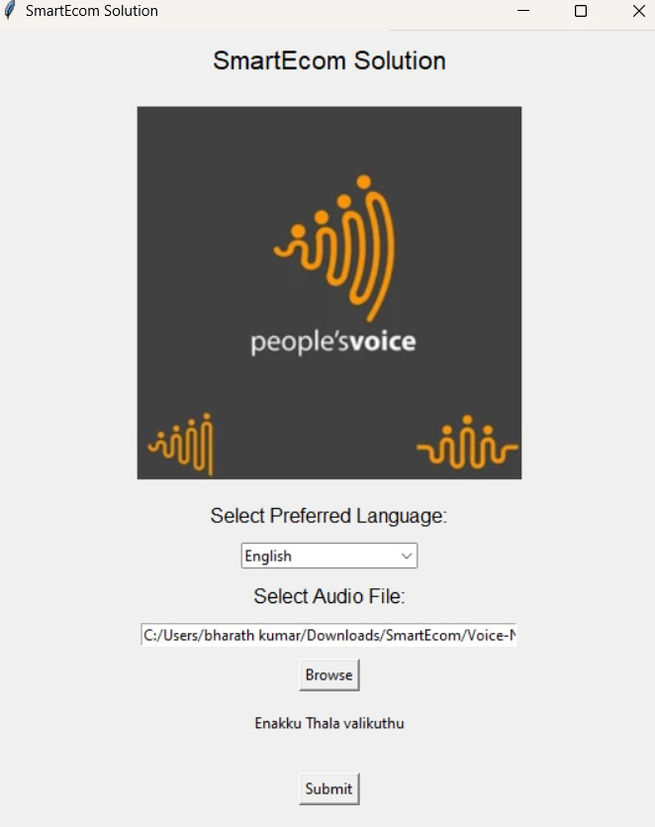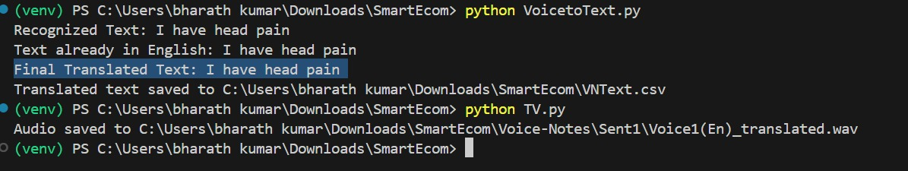

**Description of the Output Interface**

The SmartEcom Solution interface is designed to provide a user-friendly experience for voice command interactions. The layout includes the following key elements:

1. Title and Logo: At the top, the title "SmartEcom Solution" is prominently displayed, accompanied by the "people's voice" logo, emphasizing the focus on voice technology.
2. Language Selection: Users can choose their preferred language from a dropdown menu labeled "Select Preferred Language," allowing for customization according to user preferences.
3. Audio File Selection: The interface features a section where users can select an audio file by clicking the "Browse" button. This functionality enables the user to upload voice recordings for processing.
4. Submit Button: Below the audio selection, a "Submit" button allows users to submit their selected audio files for analysis and processing.
5. Additional Text: The phrase "Enakku Thala valikuthu" is included, which could suggest a personalized touch or cultural reference.

**Description of the Output Log**

The output log from the SmartEcom Solution demonstrates the processing of a voice command. Key points from the log include:

1. Recognized Text: The system successfully recognizes the spoken input, displaying "I have head pain." This indicates the effectiveness of the speech recognition capabilities.
2. Language Check: The system verifies that the recognized text is already in English, confirming the language for processing.
3. Final Translated Text: It reaffirms the recognized text as "I have head pain," indicating no translation was necessary.
4. Output Files:
   * Translated Text File: The translated text is saved in a CSV file at the specified location (C:\Users\bharath kumar\Downloads\SmartEcom\VNText.csv), suggesting that this text can be easily accessed or utilized later.
   * Audio Output: The audio version of the translated text is saved as a WAV file at the specified location (C:\Users\bharath kumar\Downloads\SmartEcom\Voice-Notes\Sent1\Voice1(En)_translated.wav), allowing users to listen to the output.

**CONCLUSION**

The development of this cognitive system provides a novel and effective solution for integrating voice commands with AI-driven product suggestions through WhatsApp. By utilizing speech recognition, natural language processing, and text-to-speech technologies, the system enables seamless communication between users and businesses. This allows users to interact in a natural, voice-based manner, while businesses can deliver personalized product recommendations efficiently, enhancing the overall customer experience.

The integration of AI into this workflow ensures that product suggestions are not only relevant but also tailored to the specific needs and preferences of each user. As the system evolves, its ability to learn from interactions and improve the accuracy of its recommendations makes it a powerful tool for driving engagement and satisfaction.

The use of WhatsApp as the communication platform is particularly beneficial, given its widespread adoption and user familiarity. This provides an accessible, user-friendly interface for a wide range of customers. By combining this with AI and voice technologies, the system offers businesses an innovative way to enhance customer support, improve sales, and streamline their operations.

Future enhancements to the system could include expanding language support to cater to a broader audience, integrating more advanced AI techniques for better recommendation accuracy, and introducing multi-turn conversational capabilities for more complex interactions. Additionally, the system could be extended to other messaging platforms and incorporate features such as sentiment analysis to further personalize interactions.

Overall, this project demonstrates the potential of integrating AI with natural language processing and voice technology to create a cutting-edge solution for personalized customer service in the e-commerce space.

**FUTURE WORK**

The **SmartEcom Solutions** project offers significant opportunities for expansion and improvement, ensuring the system continues to evolve with user needs and technological advancements. The following areas outline the key directions for future development:

1. **Enhancing the AI Model for More Complex Product Suggestion Logic**:

While the current AI model provides relevant product suggestions, future iterations will incorporate more sophisticated algorithms to handle complex user requests and refine the personalization of recommendations. This could include leveraging deeper insights from user purchase history, preferences, and behavior, as well as integrating machine learning techniques to optimize real-time suggestions for dynamic product catalogs.

1. **Advanced Speech Recognition for Accents and Dialects**:

To ensure the system caters to a diverse global audience, future work will involve integrating more advanced speech recognition technologies. These improvements will focus on better handling different accents, dialects, and variations in speech patterns, thereby increasing the accuracy and accessibility of voice input. Technologies such as deep learning-based speech recognition models can be employed to achieve higher levels of precision.

1. **Extending the System to Other Messaging Platforms**:

As part of the broader vision for **Smartecom Solutions**, the system will be expanded to support integration with multiple chat applications beyond WhatsApp. This includes platforms such as Facebook Messenger, Telegram, WeChat, and others. By enabling cross-platform compatibility, the system will be able to engage users across a variety of communication channels, enhancing its reach and flexibility for businesses. The goal is to create a unified framework that seamlessly interacts with all major messaging platforms.

1. **Integration with All Chat Applications**:

In line with the future plan of **Smartecom Solutions**, the system will be fully integrated with all major chat applications, providing a centralized solution for businesses to manage customer interactions across different platforms. This integration will enable a consistent user experience, whether customers are engaging via WhatsApp, Messenger, or other chat apps. It will also allow businesses to manage interactions from a single interface, streamlining communication and improving efficiency.